**💕HTTP Headers💕**

HTTP Headers are used by both client and server to pass additional information through HTTP requests and HTTP responses.

The types of HTTP Headers are:

* **Request Headers:** contain more information about the resource to be fetched or about the client itself. For example, the preferred formats for the response.
* **Response Headers:** contain additional information about the response, like its location or about the server providing it.
* **Representation Headers:** contain information about the body of the resource, like its *MIME type*, or encoding applied.
* **Payload Headers:** contain information about payload data, including content length and the encoding used for transport.
* *MIME type:* *Multipurpose Internet Mail Extensions, indicate the format and nature of a document*

**💕Extract Information from HTTP Headers💕**

When exploiting a web application, some information may be gathered by the HTTP Headers. In the next image example, I used burp suite to capture a HTTP request on <http://itsecgames.com/>, a vulnerable application made for practice.

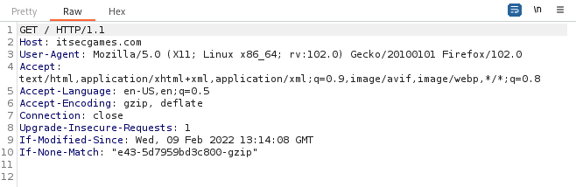

By capturing the request, you can see information like the method being used to request resources (**GET**), **Accept** represents which content types the client is able to understand, the encoding used (**gzip, deflate**), User-Agent showing the browser and system being used (**Mozilla firefox and Linux**), etc.

Sometimes sensitive information, like the application server version and technologies used by the web server, can be found on HTTP Headers, so it’s always important to check.

Another exploit option, by seeing the methods the web server accepts, by checking the HTTP Headers, you can use a software like Burp Suite to intercept the HTTP Requests, and try to send a request to the web server yourself. For example, you can make a request asking the web server for sensitive information.

The next image is an example of an HTTP Response sent by a web server, you can see the server version is Apache on the third line.

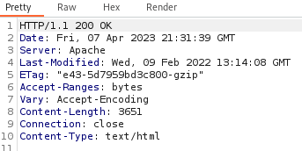

The 200 OK status code on the first line indicates the request was successfully received.